Correlation Heatmap Analysis

Introduction

Correlation measures the strength and direction of the linear relationship between two variables, commonly applied to asset returns in quantitative finance. It plays a central role in understanding how assets move relative to one another and is widely used in portfolio construction, risk management, and factor analysis. In particular, correlation helps quantify diversification benefits and highlights how these benefits can diminish during periods of market stress, a phenomenon often referred to as correlation breakdown.

In practice, correlations are not static. They evolve over time as market conditions, investor behavior, and macroeconomic environments change. As a result, static correlation estimates can be misleading, especially during regime shifts such as financial crises or sudden risk repricing events.

Mathematical Background

The most commonly used measure of correlation in finance is the Pearson correlation coefficient, defined as:
$$ρ_{X,Y}=\frac{\text{Cov}(X,Y)}{σ_{X}σ_{Y}}$$
where:
- $ρ_{X,Y}∈[-1,1]$
- $+1$ indicates perfect positive correlation
- $0$ indicates no linear relationship
- $-1$ indicates perfect negative correlation

This measure captures the degree to which two asset returns move together on a linear basis and forms the foundation for correlation-based risk analysis.

Motivation and Objectives

The objective of this project is to construct a dynamic correlation heatmap across multiple asset classes, including equity indices, foreign exchange pairs, interest rates, and commodities. By applying rolling correlation windows, we aim to observe how inter-asset relationships evolve through time rather than relying on static averages.

A key motivation is to compare correlation structures during calm market conditions versus stress periods. During market drawdowns, correlations often rise sharply as investors de-risk simultaneously, reducing diversification benefits precisely when they are most needed. Visualizing these dynamics allows us to better understand systemic risk and cross-asset contagion

Correlation Heatmaps as a Research Tool

Correlation heatmaps provide an intuitive and compact visualization of pairwise relationships across a large set of assets. Each cell in the heatmap represents the correlation between two assets at a given point in time, with color intensity indicating the strength and direction of the relationship. When extended dynamically using rolling windows, heatmaps become a powerful diagnostic tool:
- Rising correlations across asset classes can signal risk-off regimes
- Stable or low correlations are often associated with risk-on environments
- Sudden shifts in correlation structure may act as early warning signals of regime transitions

By annotating these heatmaps with known macroeconomic or financial stress events, we can directly link changes in correlation behavior to broader market regimes.

Market Regimes and Risk Framework

To interpret the observed correlation dynamics, we adopt a risk-on / risk-off framework. Risk-on regimes are typically characterized by lower cross-asset correlations and greater dispersion in returns, reflecting selective risk-taking by investors. In contrast, risk-off regimes exhibit elevated correlations as capital moves defensively and assets begin to trade more uniformly. The following table summarizes key market regimes used in this analysis and how they align with the risk-on and risk-off classification.

Regime | Typical Environment | Market Characteristics | Assets That Tend to Perform Well | Assets That Tend to Underperform
Risk-On | Economic growth, easy financial conditions | Rising equities, low volatility, tight credit spreads | Equities (growth, EM), high-yield credit, commodities | Government bonds, gold, safe-haven FX
Risk-Off | Crisis, uncertainty, tightening conditions | Equity sell-offs, volatility spikes, correlations converge | Government bonds, gold, USD, JPY, defensive equities | Equities, high-yield credit, EM assets

Dataset and Parameters

For this analysis, we consider four major asset classes: Stocks, FX pairs, Rates, and Commodities. Each asset class exhibits unique factor sensitivities and dynamics, providing a diverse set of behaviors across different market environments. This diversity allows us to capture a wide range of responses to risk-on and risk-off events, making the analysis of rolling correlations and dynamic heatmaps more insightful and robust.

As for the period of analysis, we will be taking data from 2020 to 2025, with the data source being from Yahoo Finance.
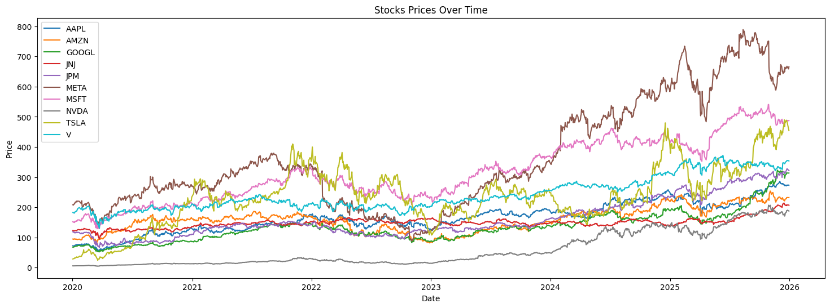
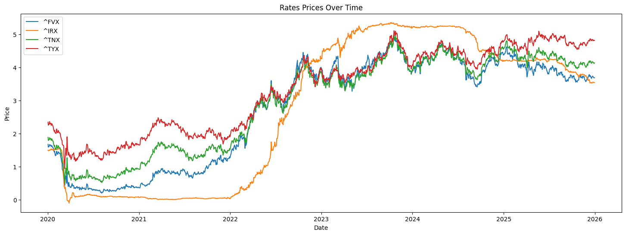
We plotted the charts above for stocks and rates so as to get a preliminary idea of how they have performed or move over time
Rolling Correlation

The rolling correlation differs from our normal asset correlation, in that instead of computing correlation across the entire period, we are using a rolling window function to compute the correlation of the assets during those period. Mathematically, it can be defined as follow:

$$ρ_{t}^{\left(X, Y\right)}=\frac{\sum_{i=0}^{n-1}{\left(X_{t-i }-{\overline{X}}_{t}\right)\left(Y_{t-i }-Y_{t}\right)}}{\sqrt{\sum_{i=0}^{n-1}{{\left(X_{t-i }-{\overline{X}}_{t}\right)}^{2}}}\sqrt{\sum_{i=0}^{n-1}{{\left(Y_{t-i }-{\overline{Y}}_{t}\right)}^{2}}}}$$

Where:
- $n$: the rolling window length
- ${\overline{X}}_{t}=\frac{1}{n}\sum_{i=0}^{n-1}{X_{t-i }}$ is the rolling mean of $X_{t}$
- ${\overline{Y}}_{t}=\frac{1}{n}\sum_{i=0}^{n-1}{Y_{t-i }}$ is the rolling mean of $Y_{t}$

Using the above formula, we computed our rolling correlations using a 30-day lookback window period. This means we are deriving the correlation across all the tickers within the asset class over the past 30-days.

Using Matplotlib FuncAnimation, we were able to produce a dynamic correlation heatmap of all the tickers within each asset class. Refer to the notebook for usage.

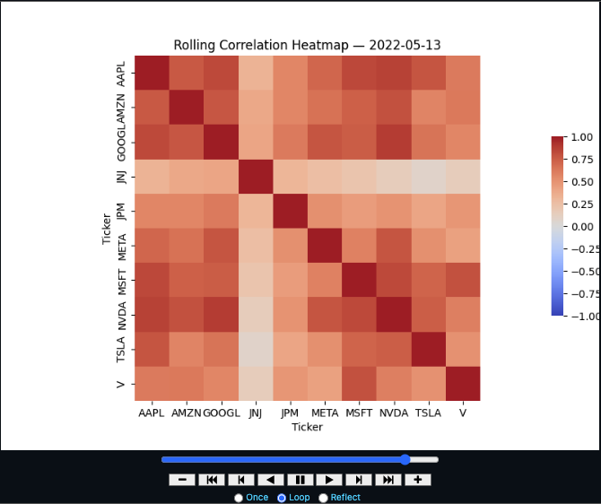

Explore the notebook and change the lookback periods or ticker symbols to see how the correlation changes over time.

Average Rolling Correlation

While rolling correlations provide pairwise measures of how two assets move together over time, analysing all pairwise correlations individually can quickly become overwhelming, especially when dealing with large multi-asset portfolios. Each rolling correlation series tells you about one relationship, but it can be difficult to extract a broader, high-level view of market behaviour from hundreds or thousands of pairwise correlations. I mean, it is nice to see the animated charts for rolling correlation, but it does not answer the broader questions in risk-management.

To address this, we compute the average rolling correlation across all assets in a given asset class or portfolio. Mathematically, for a set of $N$ assets with rolling correlations $ρ_{i,j}(t)$ at time $t$, the average rolling correlation is:
$$\overset{ˉ}{ρ}(t)=\frac{2}{N(N-1)}\sum_{i<j}{ρ_{i,j}}(t)$$
You can think of the above formula as taking the average of the correlation values in our upper/lower triangle (in blue) inside our correlation matrix.

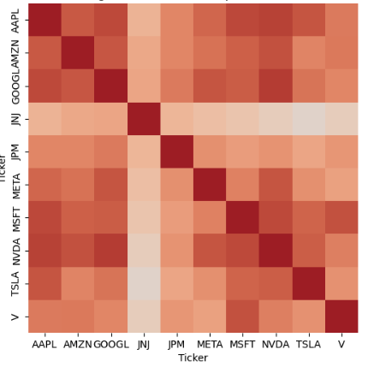
This average gives a single time series that summarizes the overall co-movement of the entire portfolio or asset class. For our python code, we simply took the average of all the correlation values (less the diagonals) using the snippet below.

Computing the rolling mean correlations and plotting the values over time, we got the following charts for each of our asset classes. We also included some risk-off and macro-shocks that heightened overall volatility to show how correlation may move.

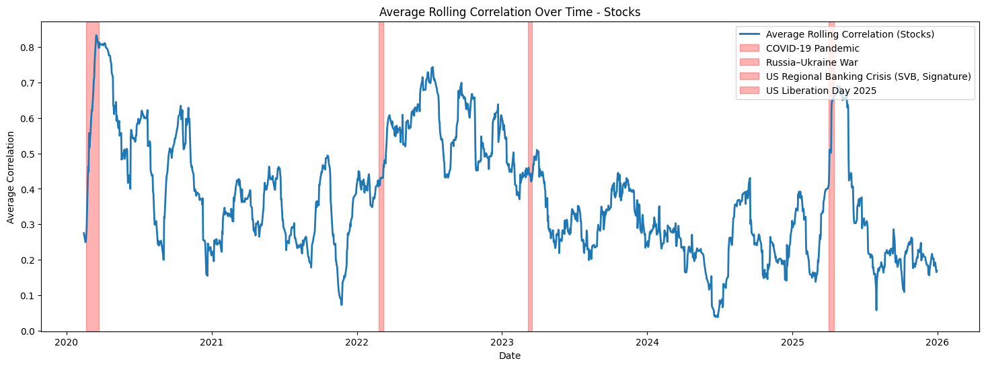
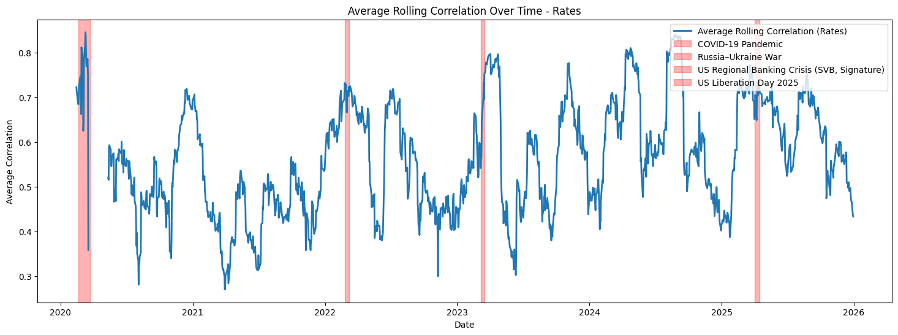
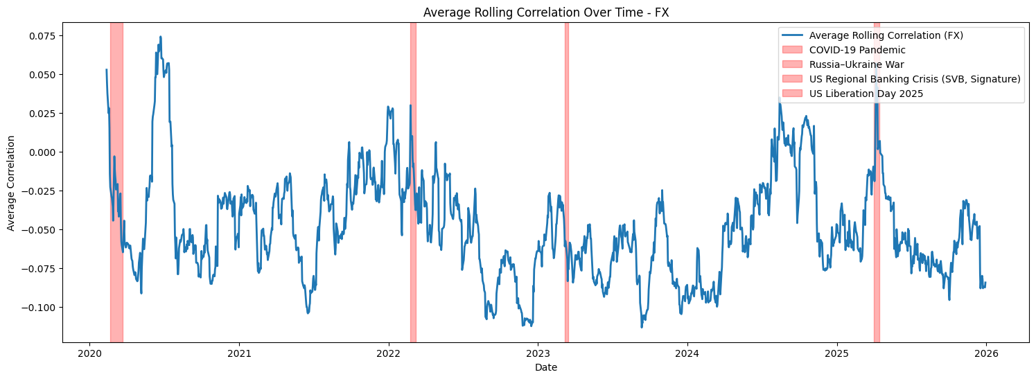
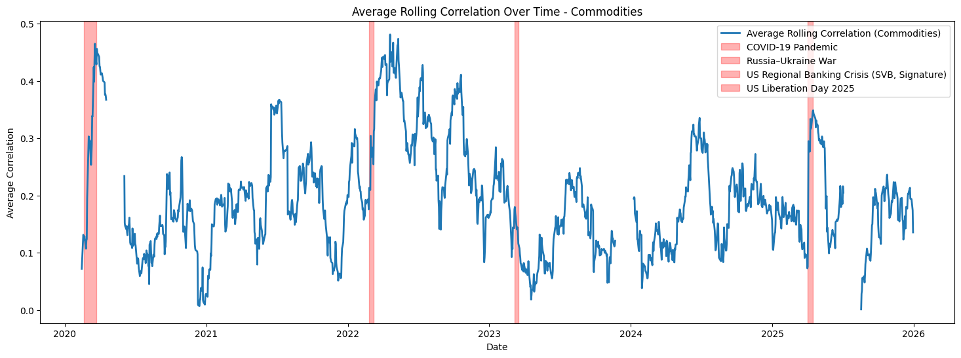

As observed, stocks and interest rates generally exhibit higher correlations during risk-off periods, reflecting strong co-movement across asset classes in times of market stress. During macroeconomic shocks, correlations among stocks tend to increase as broad market factors dominate company-specific fundamentals. In such periods, investors often reduce equity exposure across the board, prioritizing safety over stock-specific considerations, as equities are typically riskier than other assets such as bonds.

The second chart highlights that interest rates also show strong correlations, often in the range of 0.7 to 0.8, during risk-off regimes. The rates in this analysis represent U.S. Treasury yields of varying maturities, which serve as benchmark interest rates in financial markets. During periods of uncertainty, Treasury yields tend to move together due to shifts in monetary policy expectations, flight-to-quality flows, or changes in risk sentiment.

In contrast, FX pairs generally exhibit lower correlations with one another, indicating that currency movements are influenced by a broader set of idiosyncratic and cross-border factors, rather than moving strictly in unison during stress periods.

A similar pattern is observed for commodities, where correlations can vary significantly across different products. While some commodities may respond to global macroeconomic shocks in a coordinated manner, others remain more asset-specific, reflecting supply-demand dynamics, geopolitical events, or seasonal factors. Our commodity bucket consists of Gold, Silver, Crude-oil, Natural Gas, Copper, Corn and Soybeans, which could explain why correlation varies to a large extent: precious metals like gold and silver tend to move together as safe-haven assets during market stress, energy commodities such as crude oil and natural gas are influenced by global demand, supply constraints, and geopolitical tensions, while agricultural products like corn and soybeans respond to crop yields, weather conditions, and trade policies. As a result, the overall correlation structure within commodities is a complex mix of macro-driven co-movement and asset-specific dynamics.

Rolling Correlation Analysis

We will now study how a given asset of our choice correlates with their peers on a rolling basis. A few tweaks to our existing code would do the job. On top of that, we can also group by asset classes or sectors to see whether correlation exists on a sector and class level.

1. Cross-sectional or inter-asset analysis

In this section, we examine cross-sectional correlations within the same asset class. For example, within equities, we analyse how a given stock (e.g. Stock A) correlates with other stocks (B, C, D, etc.) over time. The primary objective is to identify relative co-movement patterns across assets and detect unusual or unstable correlation relationships. While assets within the same class often exhibit positive correlation due to shared macro and market-wide factors, deviations from this behaviour can be highly informative. Such deviations may arise due to:
- Differing risk profiles (e.g. cyclical vs defensive stocks)
- Business model differences (growth vs value, capital-intensive vs asset-light)
- Idiosyncratic drivers (earnings shocks, regulatory exposure, litigation risk)
- Factor exposures (size, momentum, volatility, quality, leverage)

For instance, a stock that consistently moves inversely to its peers may be acting as a natural hedge, while unusually high positive correlation may signal concentration risk or latent factor overlap. From a systematic perspective, cross-sectional correlation analysis is useful for:
- Portfolio diversification assessment
- Risk clustering and exposure management
- Identifying crowded trades
- Constructing pair or relative-value strategies
- Detecting regime shifts when correlations change abruptly

Rolling correlation measures are often used to capture the dynamic nature of these relationships, particularly during periods of market stress when correlations tend to increase.

When we ran the 30-day rolling window for a random pick in each asset class, we plotted their correlation with their respective peers.

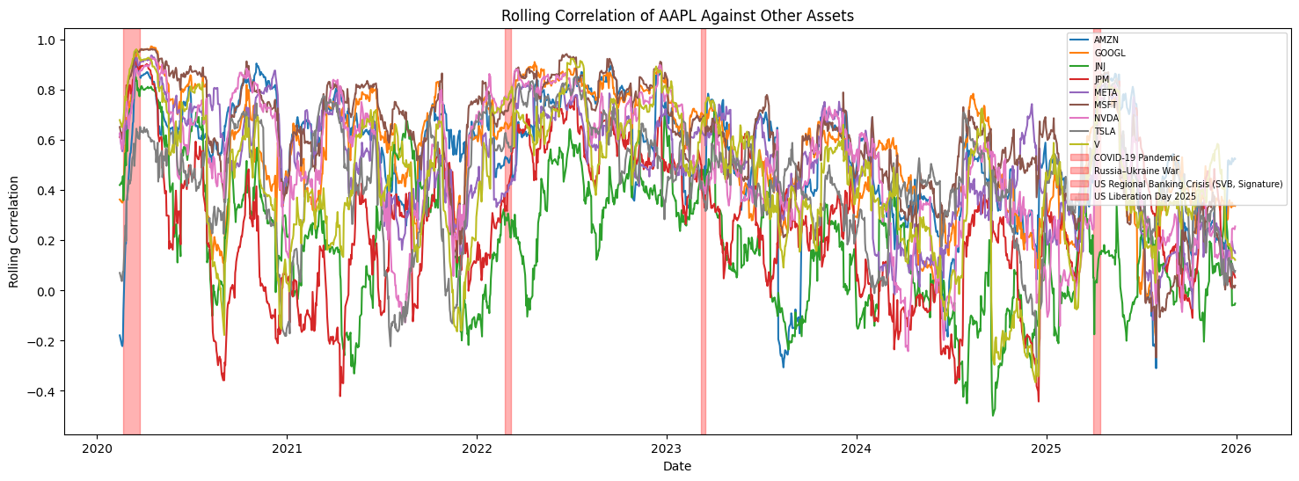
Interestingly, when comparing AAPL with its peers, we observe highly similar rolling correlation dynamics over time. A notable pattern emerges around periods of macroeconomic stress (indicated by the vertical red bands), during which correlations consistently rise to the 0.6–0.9 range.

This behaviour reflects a well-documented phenomenon in financial markets: correlations tend to spike during risk-off regimes. In such periods, equities are broadly perceived as risky assets, leading to synchronous selling across stocks regardless of firm-specific fundamentals. As a result, idiosyncratic differences diminish and common market factors dominate, driving stronger co-movement across equity returns.

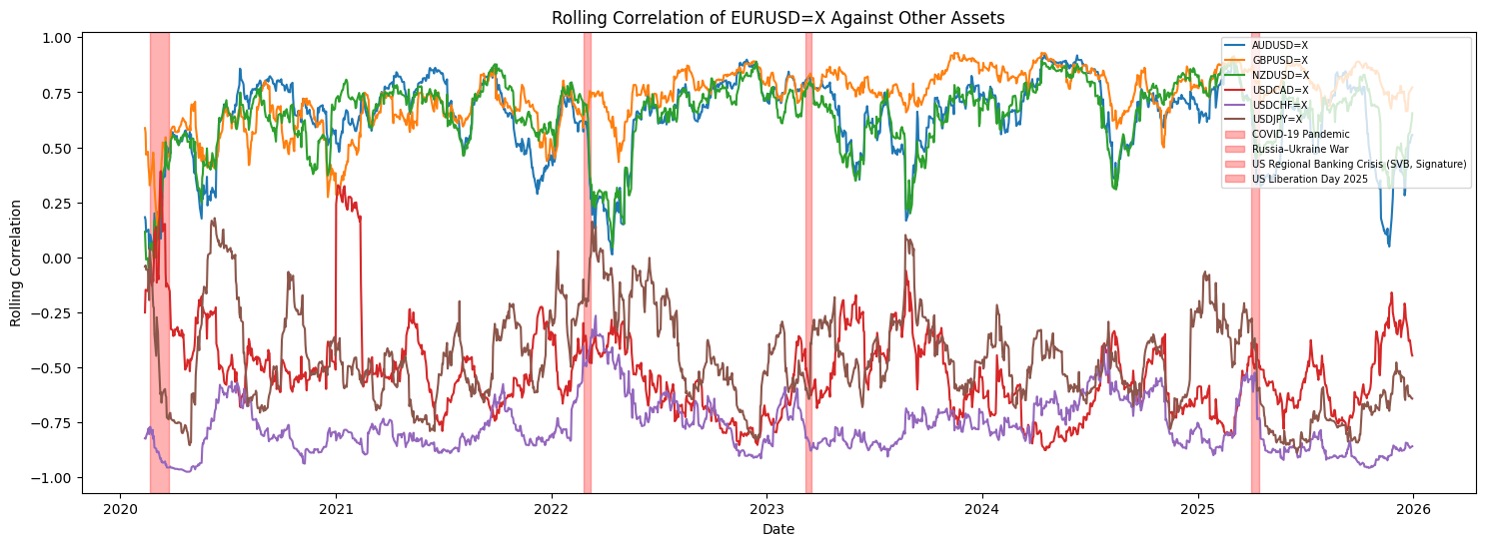
When we picked EURUSD=X against its other peers, we start to notice some interesting patterns in the rolling correlation chart. AUDSUD=X, GBRUSD=X and NZDUSD=X all displayed positive correlation with EURUSD=X, while USDCAD=X, USDCHF=X and USDJPY=X all showed negative correlations. But further inspection yielded the fact that USD was the base currency for USDCAD=X, USDCHF=X and USDJPY=X. Therefore, extra care has to be taken when analysing the rolling correlations of FX pairs, since the order of the base currency matters and needs to be constant.
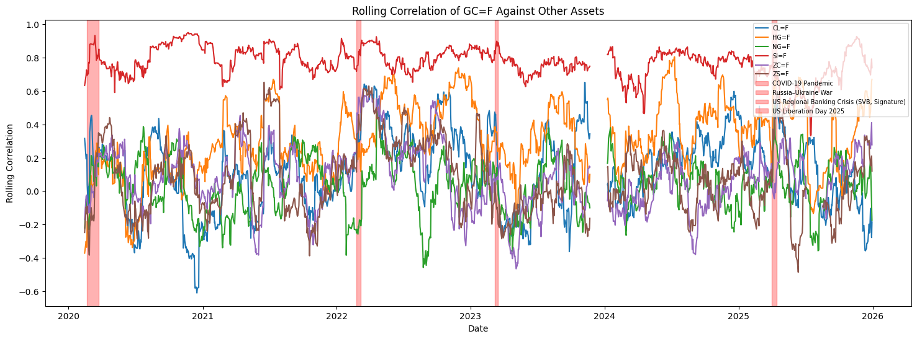
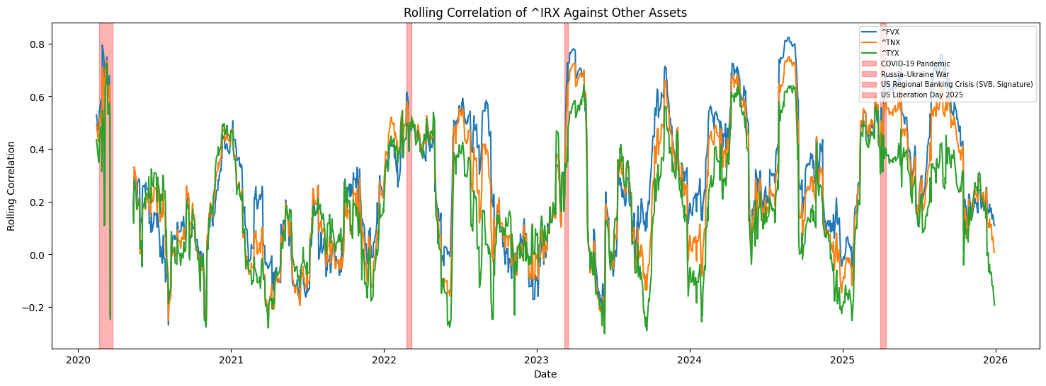

Commodities and rates display behaviour analogous to equities, with assets within each category showing consistent co-movement dynamics across time, reflecting their sensitivity to common macroeconomic and policy-driven factors.

2. Sectoral or Industry specific analysis

In this section, we extend the analysis to examine correlations across different sectors or industries, and in some cases, across different asset classes altogether (e.g. equities vs commodities, equities vs rates). Sectoral correlation analysis helps us understand how macro-economic forces, business cycles, and structural dependencies influence asset behaviour. Unlike cross-sectional analysis within a single asset class, sector-level correlations often reflect top-down drivers, such as:
- Interest rate changes
- Inflation expectations
- Commodity price movements
- Supply chain linkages
- Policy and regulatory shifts

For example:
- Energy equities may exhibit strong correlation with crude oil prices
- Financial stocks often correlate with interest rates or yield curves
- Defensive sectors (e.g. utilities, healthcare) may show lower or negative correlation with cyclical sectors during risk-off regimes

This type of analysis is particularly valuable for:
- Macro-aware portfolio construction
- Sector rotation strategies
- Stress testing portfolios across economic regimes
- Identifying natural hedges between sectors
- Understanding contagion effects during crises

By analysing how sector-level correlations evolve over time, we can gain insight into regime dependence, where relationships that hold in normal conditions may break down or invert during periods of market stress.

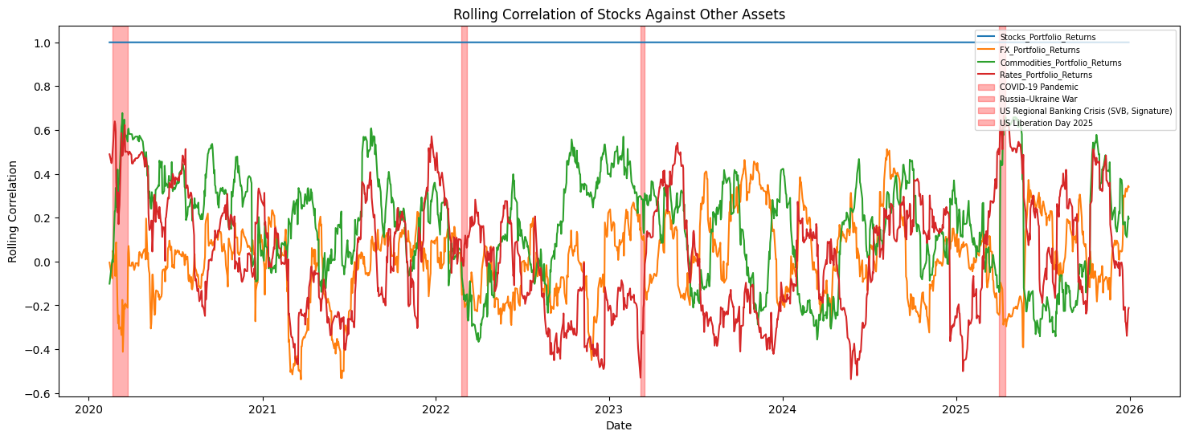
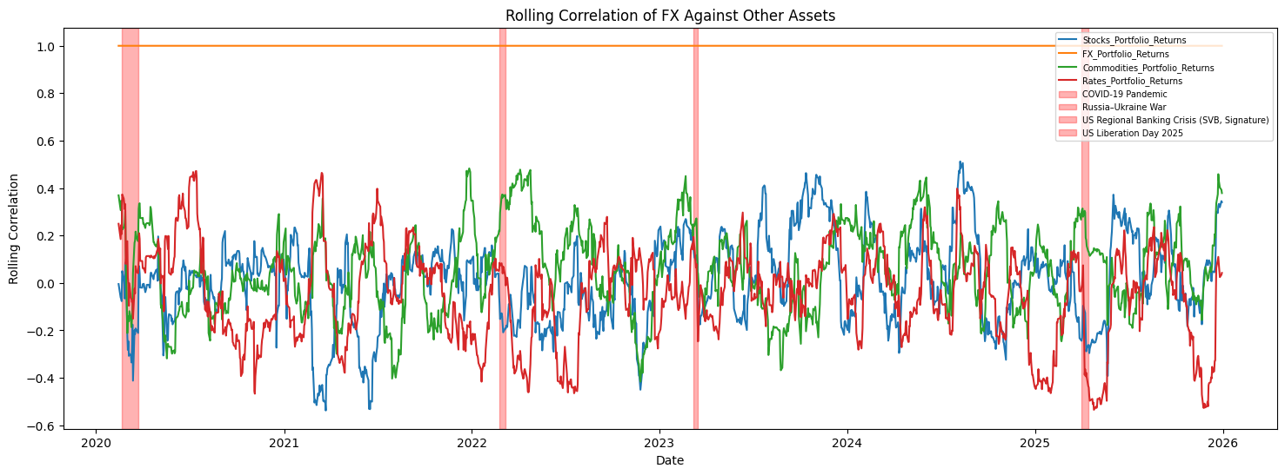
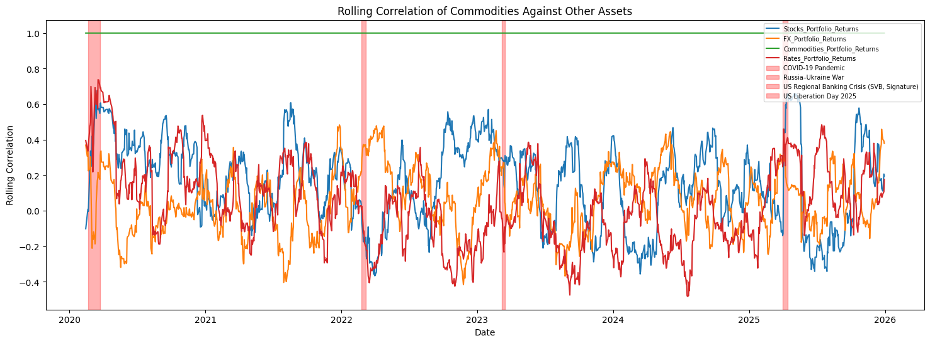
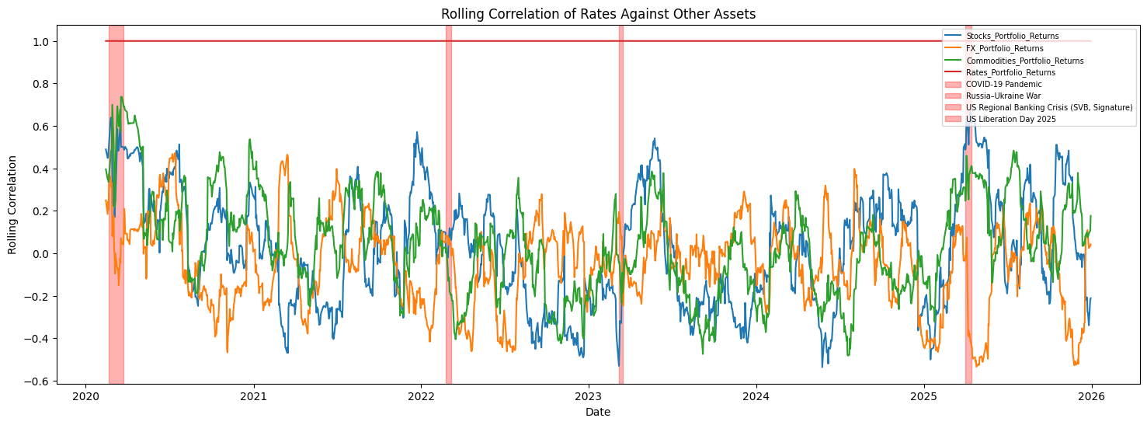
As we extend the analysis to cross–asset class correlations, we observe that correlations are generally low for most of the sample period across asset comparisons. This suggests that returns across different asset classes are largely driven by distinct idiosyncratic and sector-specific factors, such as differing macro sensitivities, policy transmission channels, and underlying economic functions.

The persistence of low cross-asset correlations also indicates a degree of structural independence between markets under normal conditions. From a portfolio construction perspective, this characteristic is particularly valuable, as it enables effective diversification, reducing overall portfolio volatility and drawdowns without necessarily sacrificing expected returns.

